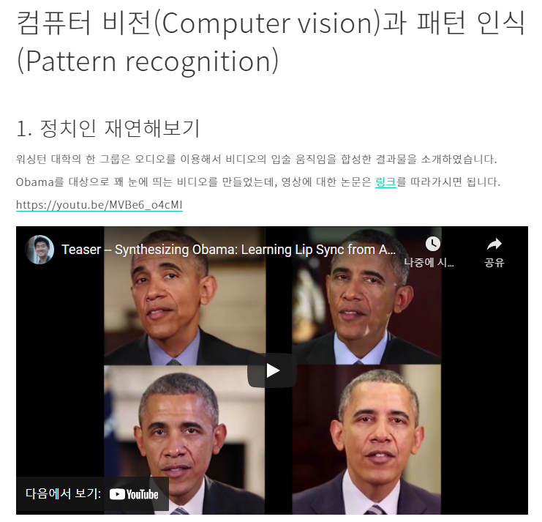

링크 : <http://youtu.be/MVBe6_o4cMI>

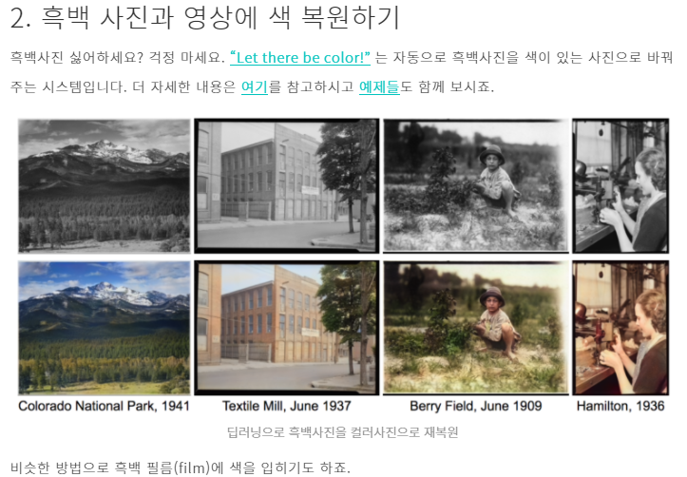

링크 : <https://www.youtube.com/watch?v=ys5nMO4Q0iY>

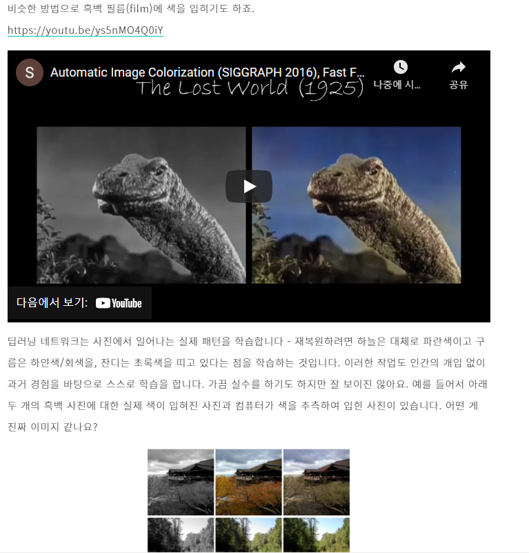

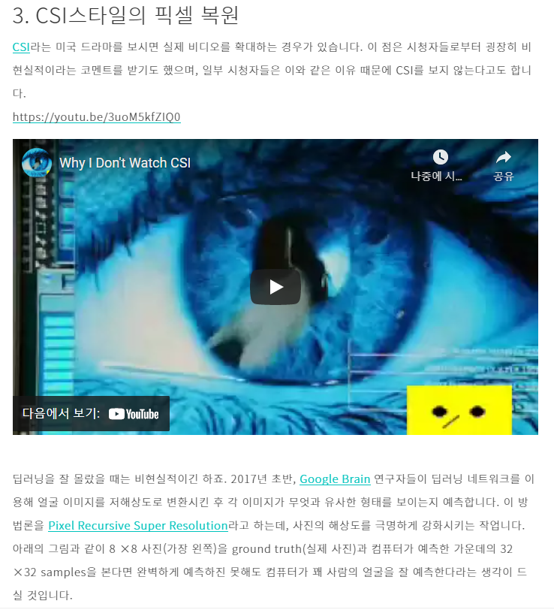

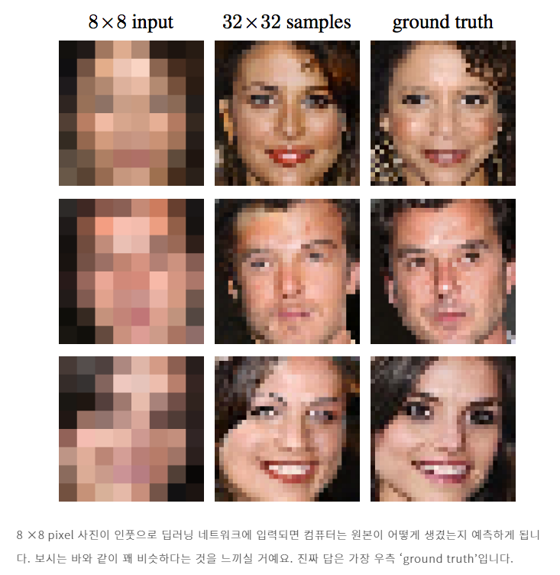

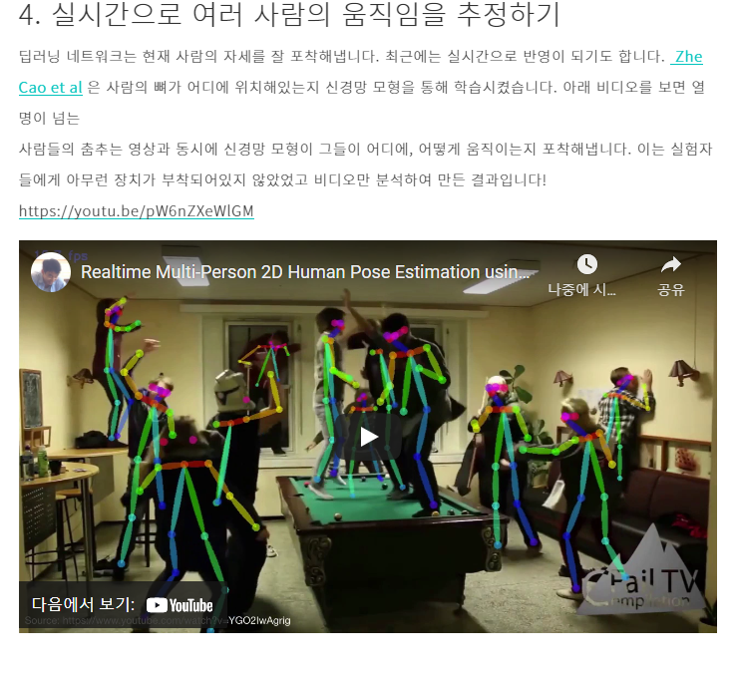

링크 : <https://www.youtube.com/watch?v=pW6nZXeWlGM>

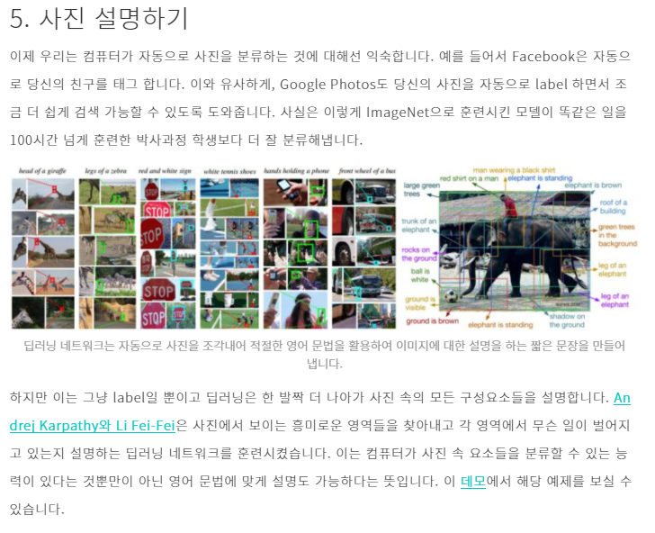

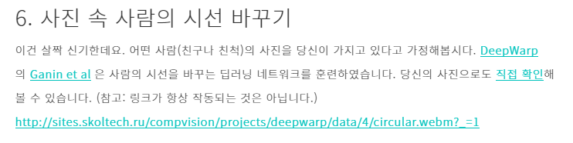

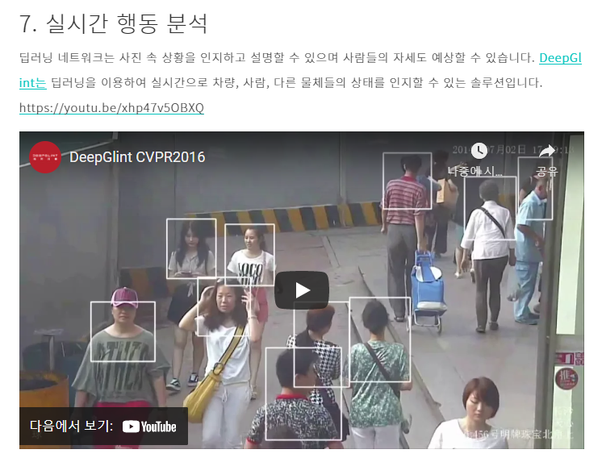

링크 : <https://www.youtube.com/watch?v=xhp47v5OBXQ>

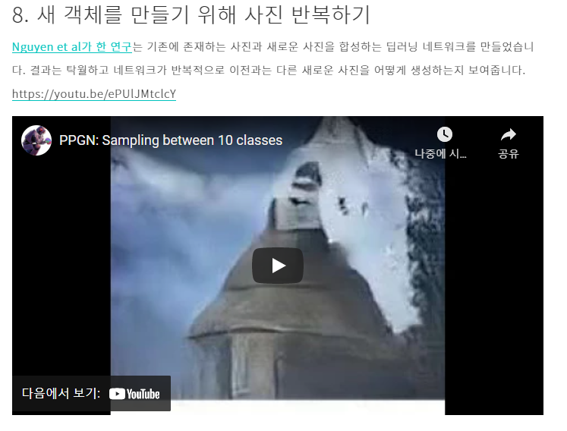

링크 : <https://www.youtube.com/watch?v=ePUlJMtclcY>

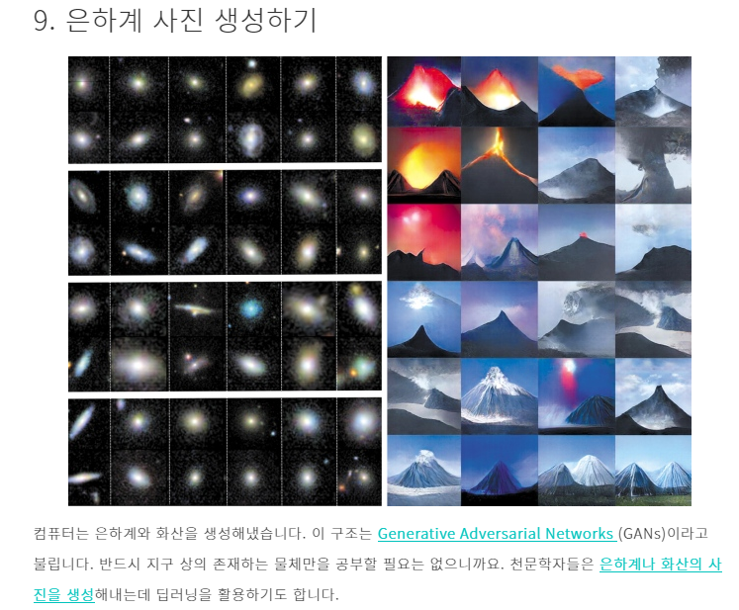

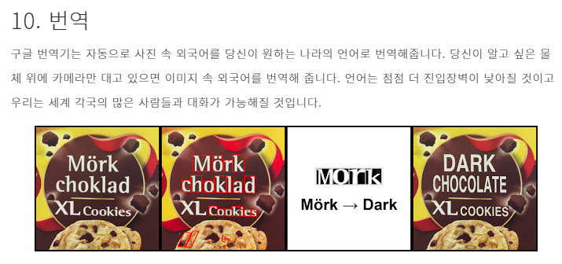

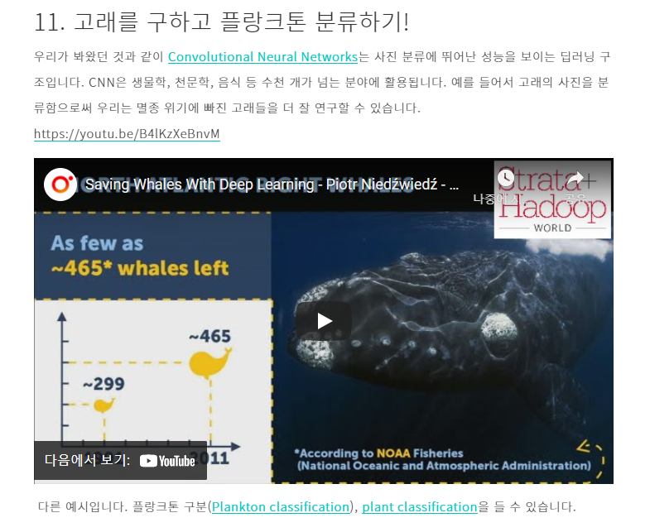

링크 : <https://www.youtube.com/watch?v=B4lKzXeBnvM>

